The Saint Philomena Apostolate Homeschool Choir
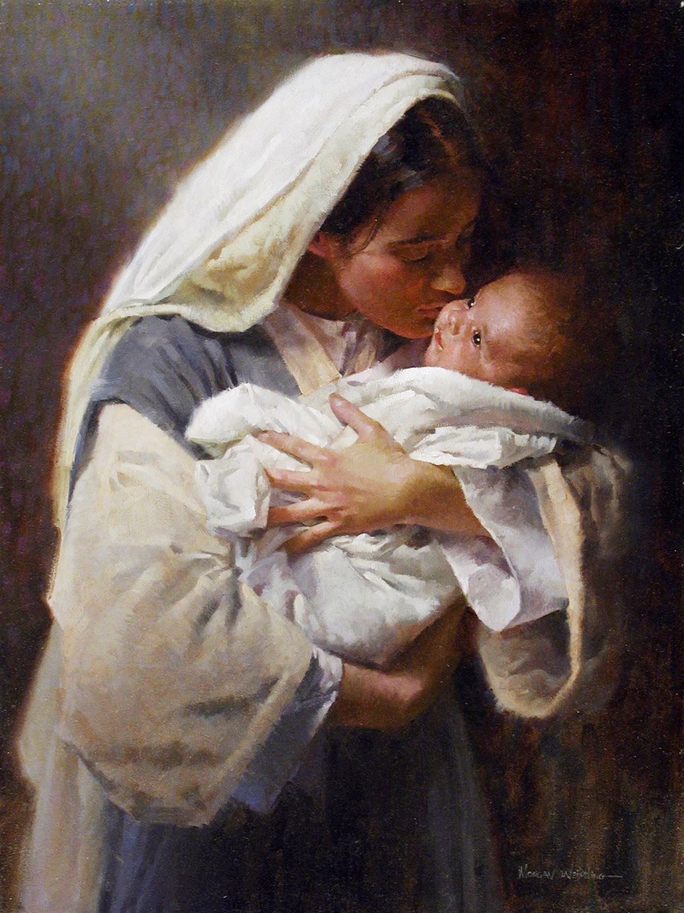
Christmas Concert
December 2018

O Come O Come Emmanuel
The Angel Gabriel
O Come All Ye Faithful – Adeste Fidelis
Lo How the Rose ‘Er Blooming
Dona Nobis Pachem
Cor Jesu
Carol of the Bells
Ave Maria
Silent Night ~ Night of Silence
Coventry Carol
Child of the Poor ~ What Child is This
O Holy Night
Joy to the World
Glory to God in the Highest

